**These special rules need to be applied to Category 720E games.**

Game names:

Altira: Cleopatra: Legend of the Snake

DW: Egypt: Land of the snakes

Category 720E special rules

**IMPORTANT: This game is to be assembled to a 94.50 RTP% ONLY. No other RTP version shall be available due to game math restrictions.**

(Note.. this is a 3x4x5x4x3 reel game but let’s assemble the reels in a pyramid looking shape / background to match please.)

1) >We will implement the usual bonus anticipation sound and slowdown of reel blurs.

2) >There shall NOT BE a symbol hiding mechanism in this game. Symbols shall appear on reels similar to any other regular slot game.

3) >> We will use one sound for when the BONUS lands on a reel, and the Bonus symbol shall do a large pulse animation when it lands on a reel, and NO special sound for when WILD lands on a reel.

4) Bonus game sequence:

a) When 5 bonus symbols land the bonus game trigger occurs

b) a special sound and full screen animation shall occur when 5 bonus symbols land. Once animation clears, it reveals a bonus game notification “Congratulations, you have triggered the Snake Bonus game!” [Continue]

c) Follow the game instructions below:

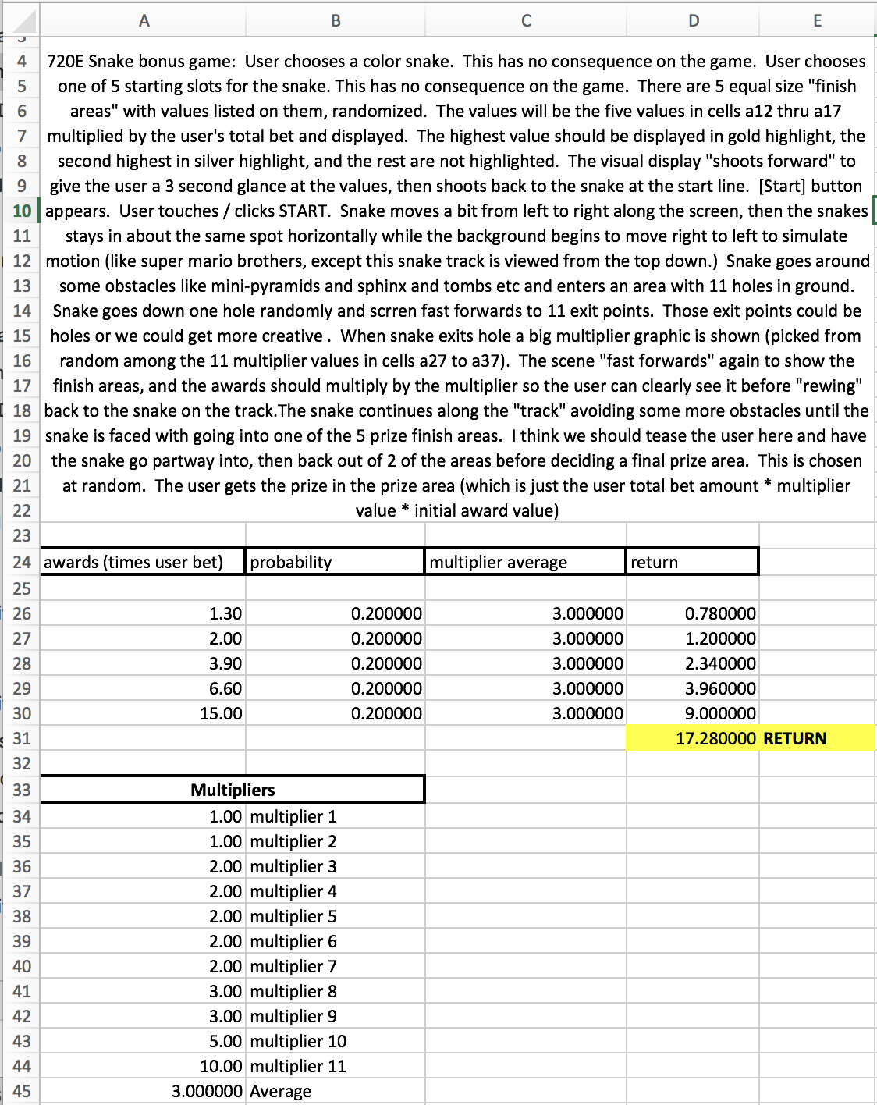

d) when the bonus spins game is over, a notification shall appear with text: “Congratulations, you won {win value}! [CONTINUE]

e) after clicking [Continue] the user shall go back to the regular base game.